**Hand on Assignment 3**

**Bhuvanesh P MM19B027**

**Lattice parameters and computation time**

|  |  |  |  |  |  |  |  |  |
| --- | --- | --- | --- | --- | --- | --- | --- | --- |
| System | K-points | a (AO) | b (AO) | c (AO) |  |  |  | Total CPU time (s) |
| Unit cell | 5 X 5 X 5 | 4.04265 | 4.04265 | 4.04265 | 90.0000 | 90.0000 | 90.0000 | 3.551 |
| Unit Cell | 10 X 10 X 10 | 4.03780 | 4.03780 | 4.03780 | 90.0000 | 90.0000 | 90.0000 | 9.303 |
| Primitive cell | 5 X 5 X 5 | 2.88005 | 2.88005 | 2.88005 | 60.0000 | 60.0000 | 60.0000 | 0.868 |
| Primitive cell | 10 X 10 X 10 | 2.85523 | 2.85523 | 2.85523 | 60.0000 | 60.0000 | 60.0000 | 3.084 |

**Unit cell Images**

**Primitive**

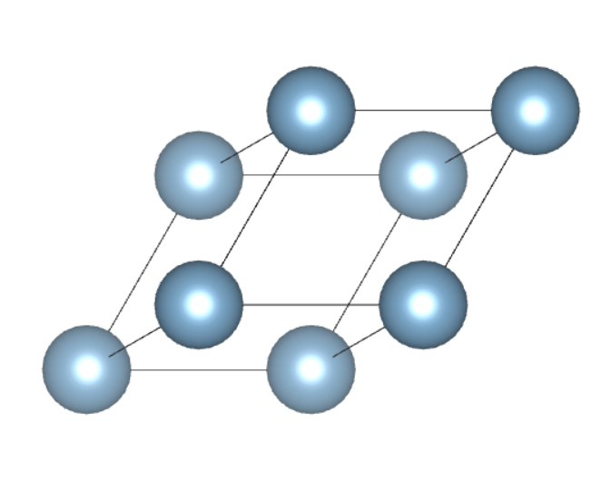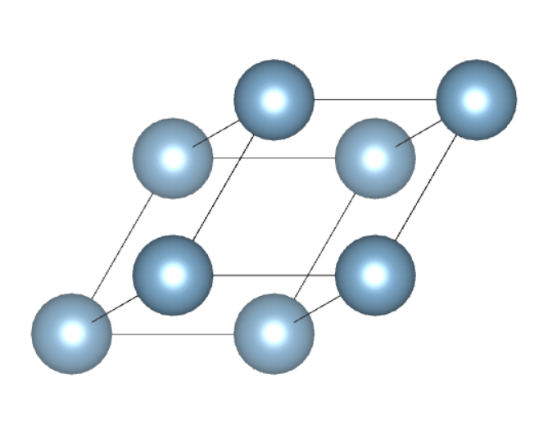

Primitive unit cell constructed with 5x5x5 and 10x10X10 K points. The structure is same but the lattice parameters are different

**Unit Cell**

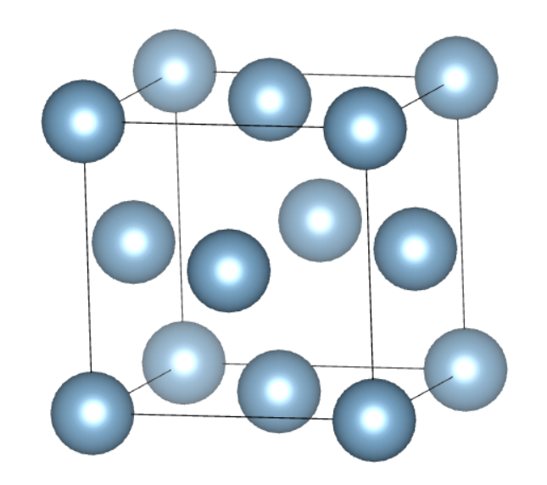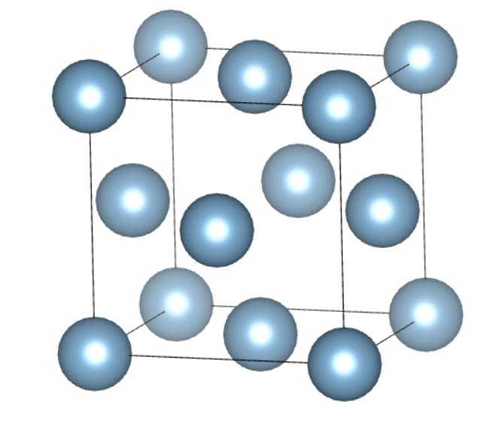

Unit cell constructed with 5x5x5 and 10x10X10 K points. The structure is same but the lattice parameters are different

The difference in computation time for different k points comes as we are involving more points in cell construction in 10 k points as compared to 5. More points – More computation time.

The difference in computation time for primitive and unit cell comes as a unit cell is far more complicated than a primitive, hence it takes a lot of computation to construct it and thus lot of time.